Top high-rated episodes of Conan dubbing
Detective Conan is an exciting Japanese detective manga series, loved by hundreds of millions of readers around the world and has been adapted into a movie. Conan series has many episodes. Among them, here are the best and highest-rated episodes of Conan dubbing!

1. School Ghosts School
Ghosts are the 6th episode in the Detective Conan series, which was released on April 20, 2002. The content of this episode is about detective Conan and his friends wandering the streets and alleys of London, England, even to places where Sherlock Holmes used to live to Purpose search for clues to catch Jack the Ripper (JTP) - a dangerous killer. When the movie came out, it brought in about 3.38 billion yen in revenue. Compared to the sales of the previous 5 seasons, School Specter is much higher.

School Ghosts - is the most popular Conan dubbing episode

2. The skyscraper
bomb The skyscraper is one of the most popular episodes. The episode was officially released in 1997 in Japan and quickly acquired by many countries. Although compared to other episodes, the skyscraper does not have many thrilling detective details, but it gets points when continuously placing the characters in a "thousand pounds hanging hair" situation makes viewers extremely nervous. .

3. Crimson Love Song
If you love the Detective Conan , you definitely can't miss this episode. This is the 21st episode in the series Detective Conan and officially premiered on April 15, 2017. In Vietnam, the film was released on September 8, 2017.
The content of the crimson love love episode tells the details surrounding the bomb explosion at Nichiuri TV station along with the invention of Karuta - the former Japanese champion and the mysteries that many people do not know about the award. Karuta. In the episode, a new character appears, Ooka Momiji, she claims to be Hattori's fiancée. Her appearance makes things more complicated and complicated.

The crimson love song is extremely attractive
According to statistics, the crimson love song is the highest-grossing episode in the series Detective Conan because it fully converges elements such as detective, action and affection to engage viewers.

4. The 11th striker
This is also an extremely HOT episode of Conan dubbing, belongs to the 16th episode in the series. This episode revolves around a plot to bomb a series of stadiums taking place at the national championships. With thrilling, dramatic and unexpected situations, it is not difficult to understand when this episode brings high sales for the producer.

5. 15 minutes of silence
If you are a fan of Detective Conan, you definitely cannot ignore the 15-minute quiet episode that was released in Japan on April 16, 2011. In this episode, there are many interesting details and two more groups of characters appear:
- One, the Tokyo Police Department with Inspector Megure and Sato - a beautiful young policewoman and the fool Takagi
- Hai, the Detective Team. Class 1B consists of Ayumi, Genta, Mitsu, Haibara Ai

15 minutes of super interesting tranquility

6. Fire sunflower
This is also a episode of Conan dubbing rather interestingand attracting a large number of followers. This episode is inspired by paintings of sunflowers painted by Vincent van Gogh - the artist world genius. The content throughout refers to unsolved mysterious stories that happened at the place where the sunflower painting collection was launched. Compared to many other episodes in the series, flaming sunflowers are not thrilling, thrilling, but strange and different.

7. The Maze in the Old City
Released in 2003 and belongs to the 7th volume in the series Detective Conan. The labyrinth in the old city mainly tells about the skilled swordsman and the bow has caused 5 consecutive murders, causing Toyoko police to face many difficulties. At the same time, this episode also tells the story of Hattori's first love.
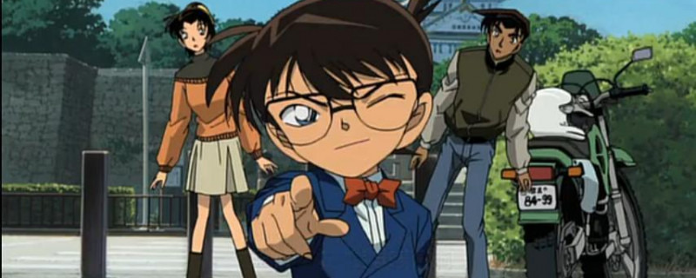
Watch the episode of the labyrinth in the old city

8. Dark Nightmare
The next episode of Conan that you should not miss is the dark nightmare of the 20th episode of the series. The entire content of this episode focuses mainly on the Black Organization while chasing an amnesiac member who accidentally encountered Conan. In this episode there are not many virgin elements but more action elements.

Above are the episodes Conan dubbing well, is interested by many people and has the highest revenue. The time of this episode was uploaded to website. Pops.vn If you do not have time to enjoy, you can visit the website to track. In addition, there are many other episodes here, which are sure to satisfy the passion of those who love Detective Conan.

